Training Records

Document & Version Control

Document Control Checklist

Name | Title | Business Unit

Version Control:

Version No. | Author | Date of Changes
1.0 | RiskLogic Pty Ltd

Produced by RiskLogic Pty Ltd
Level 7, 74 Castlereagh St
Sydney NSW 2000
Telephone: 1300 731 138
Email: info@risklogic.com.au

The contents of this document are strictly confidential and must not be reproduced without the express permission of RiskLogic. RiskLogic does not accept any liability including claims, demands, suits, judgments, damages or losses including any costs, expenses and legal fees that may occur against RiskLogic resulting from the use of this document by any party.

© Copyright RiskLogic 2016. All rights reserved.
Training Records

Training Records can be used to record and report on the training undertaken by your employees. All employees in the system can have a training record. For those imported into the system, the only fields which can be edited is the training record, however, if employees are manually added into BC-3, training record and employee details can be edited.
There are a few ways you can add/edit training records in BC-3.

- Individually

Training records can be individually added by going into the left-hand menu, selecting Administration > People > Employees > Search.
Search for an employee name, view record and select ‘Training Record’.
You can add a new record manually through this option including adding in the role the employee had during the training e.g. Participant, Facilitator, Observer or you can view existing records from this page as well.
Note: Type of Training and Date fields are mandatory. You can also select whether the employee attended, or if they passed or failed the training.
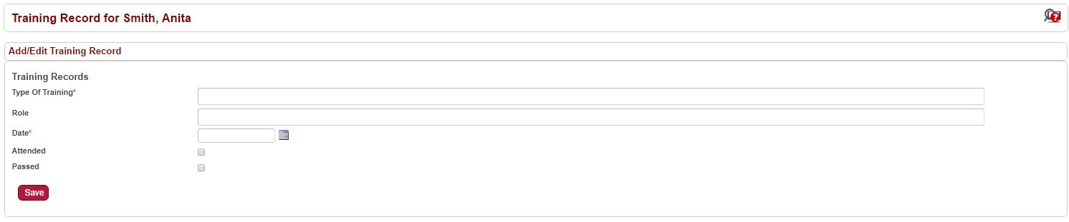
Existing records are shown in the list under ‘Training Records’. You can delete records, unlike other sections in BC-3, these will be removed from the system.
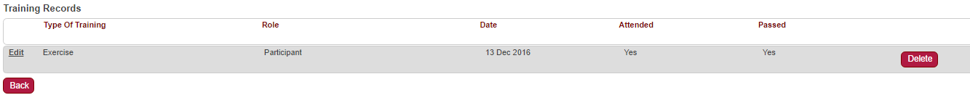
Make changes to training records by using the ‘Edit’ button.

- Using the ‘Employee Training Records’ importer

The Employee Training Records importer allows bulk updating of employees’ training records. You need to download a template which can be easily imported into the system.
The template requires the following information:
- Employee ID *
- Type of Training *
- Role
- Date *
- Attended *
  - Yes or No only. If any of these records are blank, it will cause the associated record to fail in the import.
- Passed *
  - Yes or No only. If any of these records are blank, it will cause the associated record to fail in the import.

NB: If you select ‘No’ for Attended but ‘Yes’ for Passed, the import will fail that record with a message saying the record is marked as a pass but the Employee did not attend.
Failed Imports
If a record fails on the import, but the others are OK, the records will be imported but an error message for the failed record will give you a line number to look at in your import file. If you correct this, make sure to remove the previously correct imported files before importing again to limit the risk of duplication. Alternatively, you can manually add the record for those which failed.

- Using ‘Exercises’

Another way to update a training record is by using Exercises. They can be used to either record participation in an exercise or a way to log a training course. A template must be set up for an exercise before you commence.
To ensure employee training records are updated this way, you must make sure that the ‘Is this a Training Exercise?’ checkbox is selected in the template otherwise you will create a normal exercise and the Employee Training Records won’t be updated. Once the template has been created, you need to set up the exercise in the usual way, including going through the approval process.
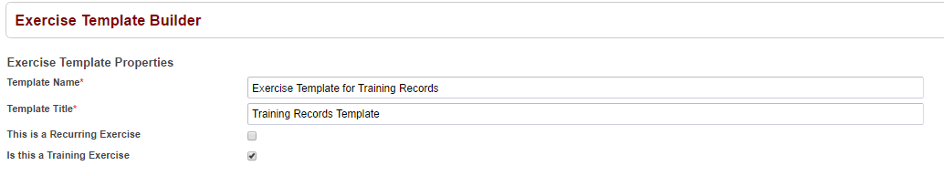
Notes
If an exercise is created to log a training course, best practice is to create it after the training has taken place. Once the exercise approval is achieved, it is closed and no amendments can be made.
The exercise can be partially configured prior to the training taking place with most of the details recorded and then details such as ‘Attended’ and ‘Passed’ being completed after the training has taken place.
Once the exercise has been approved, the Employee Training Records will be updated based on the name of the Exercise Template, even if the training date is in the future.

Reporting

A report can be downloaded of employees’ training by navigating to Reports > Employees > Employee Training.
You can search by:
- Name
- Geography/Business Area (i.e. Hierarchy)
- Date Range
- Training Type
You will need to select ‘Attended/Not Attended/All’ with the additional ability to select ‘Passed/Not Passed’ to help filter the report.
If you have selected the ‘Include Entity Responsibilities’ option, the employees’ roles and name of the entities associated with those roles are shown on the report.
Reports > Employees > Employee Training Gap Analysis
This shows a report by Employee Name and Entity Role to highlight where training has not been received. It also shows a date when the training was last attended. The ‘Future Training Scheduled’ column will populate with a date if an exercise is created but not submitted for approval.
Note: if an exercise set up for training has not been approved then nothing will show in the employee record.
Reports > Employees > Exercise Participation
This is the same as the Employee Training Report but without the Passed/Not Passed option.

